Rest in space, Starman! Creative reframing of death metaphors on David Bowie’s mural in London
Laura Hidalgo-Downing and Paula Pérez-Sobrino
Universidad Autónoma de Madrid and Universidad de La Rioja
Laura Hidalgo-Downing <laura.hidalgo@uam.es>
Paula Pérez Sobrino <paula.perezs@unirioja.es>

Abstract

This article explores the way in which death metaphors written in the urban mural for David Bowie in London contribute to creatively reframing the artist’s death. While research on death metaphors has focused on traditional written genres such as obituaries and epitaphs, studies of urban memorials and shrines have focused on the creation of fandom identities, downplaying the role played by figurativity, creativity and emotional connotation. The present article aims to bridge the gap between these two areas of study by presenting a corpus-based study of 585 items written on the mural for David Bowie. The research questions are: (1) How is Bowie’s death (metaphorically) conceptualised?, (2) To what extent are death metaphors in Bowie’s mural creative?, and (3) What is the relationship between the metaphorical framing of Bowie’s death and the projection of emotional connotations? The findings of our study reveal that Bowie’s songs emerge as a highly productive metaphorical source domain to understand the artist’s death, in which fans recontextualise lines from Bowie’s lyrics in creative and positive ways.

Keywords: creative metaphor, David Bowie mural and shrine, death metaphors, emotional connotation, recontextualization

Introduction
Previous research on the conceptualization of death has focused on the description of the types of metaphors found in English and in other languages (Lakoff and Turner 1989, Sexton 1997, Bultnik 1998, Benczes and Burridge 2019, Wachowski and Sullivan 2021), typically in obituaries and epitaphs (Marín-Arrese 1996, Sexton 1997, Bultnik 1998, Crespo Fernández 2006, 2011, 2013, Heyndericks 2021) but also in other genres and linguistic forms of expression, such as poetry (Lakoff and Turner 1989), fairy tales (Herrero Ruiz 2007), idioms (Lu 2013) and participants responses in questionnaires (Gatambuki Gathigia et al. 2018). However, within Conceptual Metaphor Theory, little attention has been paid to the creative potentiality of death metaphors in everyday discourse or to how such metaphors are expressed in less traditional genres such as the mural discussed in this article.
It has been argued that death metaphors are euphemistic strategies which speakers/writers use to deal with death, a social taboo, and with the grief felt on the death of a loved person, typically a relative or friend (Marín-Arrese 1996, Crespo Fernández 2006, 2013, Gatambuki Gathigia et al. 2018). However, public shrines display different characteristics, mostly because the nature of the socio-cultural activity is very different from other more traditional genres such as obituaries and epitaphs. For example, shrines, like memorials, often focus on the deceased celebrity’s life and not only on their death (Allan and Burridge 2006: 225), so that visiting a shrine may be partly motivated by the need to express mourning and grief on the loss of the celebrity but also because of the wish to pay them tribute.
Studies of urban memorials and shrines have focused on the creation of fandom identities and on the nature of the affective relation with the celebrity (Helmers 2001, Harju 2015), but have paid little attention to the role of figurativity. In the case of David Bowie’s death, recent research has focused on interactional stance strategies in instagram posts (Matley 2020) and on Bowie’s fandom (Cinque and Redmond 2019), but the role of figurativity is only marginally mentioned in these studies. The present study aims to bridge this gap by presenting the first corpus study of death metaphors on an urban mural which contains 585 messages. The messages written on Bowie’s mural offer an extraordinary opportunity to study how death is creatively framed through metaphor in this new discourse type. We have formulated three research questions to drive our study:

RQ1. How is Bowie’s death (metaphorically) conceptualised? This research question investigates the presence of metaphorical messages (vs. literal ones) in the mural, as well as the most salient source domains used to frame Bowie’s death.
RQ2. To what extent are death metaphors in Bowie’s mural creative? Here we investigate if (and if so, how) the metaphorical target domain Bowie’s death motivates a creative selection of source domains by Bowie’s fans. Focusing on metaphorical source domains, three dimensions of creativity are established: conventional source domains, conventional source domains developed through creative mappings, and novel one-off source domains. We investigate if there are any statistically significant relationships between these three dimensions of creativity and the choice of metaphorical source domains (RQ1).
RQ3. What are the most frequent emotional connotations of the metaphorical framings for Bowie’s death? Mourning involves a complex array of feelings, but in this study we focus on two broad categories: metaphors that evoke positive connotations, where the person wishes a better life for the deceased, and those with negative connotations, where sadness for the passing of the deceased is expressed. We discuss whether there are any visible links between the projection of such emotional connotations and the choice of metaphorical source domains (RQ1) and creativity (RQ3).
The remainder of this paper is structured as follows: we first introduce the background to our study, followed by the data and methodology, the results and discussion. The article closes with a summary of the main findings and suggestions for further research.
Bowie’s mural and shrine in London
The shrine for David Bowie (see Figures 1 and 2 below) is an urban site which originated on 10th January 2016 (the day of his death), when fans spontaneously started gathering to pay him tribute and express mourning at the site of his mural in Brixton, the London suburb where he used to live as a child (Holt 2016). Fans deposited flowers, letters and objects in front of the mural and started writing messages on the surrounding walls.
The mural shows David Bowie’s face in his persona of Aladdin Sane/Ziggy Stardust, with a thunderbolt crossing his face (see Figure 1). It was created by street artist James Chocran (Jimmy C) as a commission for the Victoria and Albert (V&A) exhibition David Bowie is in 2013. The mural was exhibited on the external wall of the department store Morley’s and should have been removed after the exhibition ended, but it remained. Given the immense attraction the mural had on fans on the day of his death and subsequent days, it was quickly declared officially protected and the originally ephemeral creation became permanent.
The year following Bowie’s death, 2017, there was a new gathering of fans again on 8th January, who then celebrated what would have been the artist’s 70th birthday. The mural then acquires a new more positive meaning, it becomes a site to preserve memory alive, for fans to enact a fictional encounter with the star, ‘as if’ he were still there. This combination of mourning and the expression of tribute and positive feelings can be observed in the messages written by the fans.

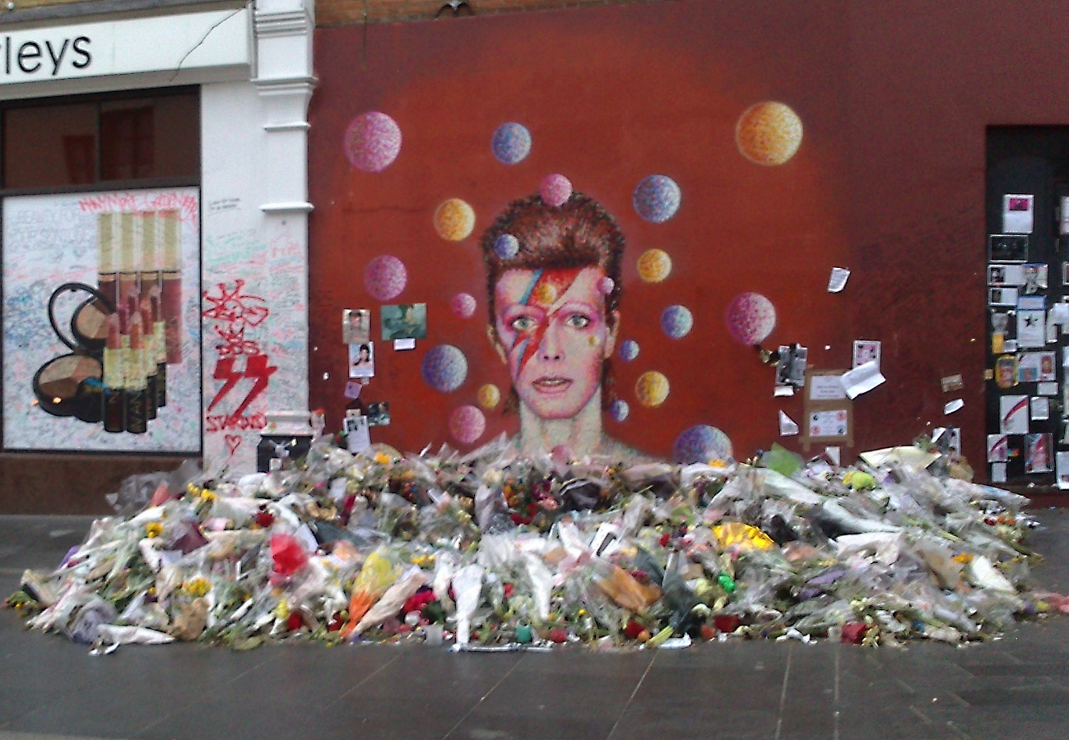

Figure 1. David Bowie’s mural and shrine in Brixton, London (Photo taken on 17 February 2016)
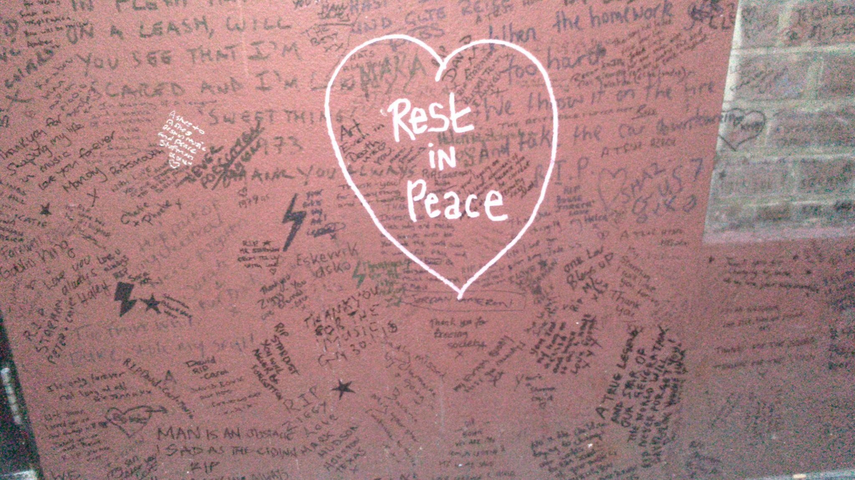
Figure 2. Close-up of messages written on David Bowie’s mural in Brixton, London (Photo taken on 17 February 2016)

David Bowie’s mural and shrine are examples of what has been termed “vernacular creativity”, that is, the display of unauthorised unsanctioned texts in public spaces creating complex creative layers of meaning (Carrington and Dowdall 2016: 425). Some shrines are temporary, but others, such as the one arising on the site of Bowie’s mural, have become permanent, in a way transcending their original nature as ephemeral expressions of collective action.
The nature of the celebrity shrine as an urban unofficial genre with very specific spatial affordances makes it different from other more traditional genres which typically contain death metaphors, such as epitaphs and obituaries, or online blogs and memorials on the death of celebrities. Thus, writing on an urban mural imposes restrictions in terms of time and place which are different from those of other genres such as epitaphs and obituaries: the messages are prototypically short and concise, they are typically more informal and often imaginative and creative and, in principle, they have an ephemeral nature, though this has not been the case in Bowie’s mural. Urban shrines are created spontaneously, typically in locations which are significant for the celebrity’s life, such as their home, a recording studio or a location which appears on the cover of an album. Urban shrines, as a form of transgressive urban discourse (Carrington and Dowall 2016: 416) have a changing nature, as they are the result of the collective action of fans who visit the shrine over time, so that they are never exactly the same. Thus, although the posts on the mural are individual items written by different people, the mural itself is a collective product of social action which needs to be understood as a form of collaborative discursive and social practice (van Dijk 2009, Jones 2016) closely linked to socio-cultural practices of Bowie’s fandom community. As such, Bowie’s mural is an example of how creativity is a powerful and complex cognitive, socio-cultural phenomenon which is grounded on individual acts of everyday creativity (the fans’ writings on the mural) that have the potential to change a given reality (the mural becomes an officially protected piece of urban art).
Visiting a shrine, like writing online posts in fandom websites, plays an important social function, as it allows fans to enact a ritual collective practice which enables them to cope with the loss of the celebrity (see Matley 2020: 7). However, unlike online posts in fandom websites and social media in which fans typically write longer comments on their feelings on Bowie’s death, (eg. “I can’t believe Ziggy Stardust died”) (Matley 2020), numerous messages on the mural show a tendency for fans to interact directly with the artist or his personas (eg. “Rest in space Starman”).
The numerous messages written by fans on the mural and the adjacent walls since the artist’s death make this site a valuable source of linguistic data to study how death is conceptualised in a highly specific cultural context. More specifically, the metaphors written on the mural provide an interesting insight into the study of creative figurativity, given the potential of the target domain death to be conceptualized metaphorically (Lakoff and Turner 1989: 14-31), and also because the world of David Bowie’s songs has created a complex fictional universe which is shared and reused by fans in different ways, creating a rich fandom identity (Cinque and Redmond 2019, Matley 2020). As David Bowie fans know, many of the artist’s songs, in particular his earlier songs, revolve around his artistic personas as Ziggy Stardust/Starman and the universe created between the publication of his albums The rise and fall of Ziggy Stardust and the Spiders from Mars (1972) and Aladdin Sane (1973). Bowie’s most well-known songs address journeys in space themes, such as Space Oddity, Starman or Life on Mars, and involve his personas as an alien or a Starman that has fallen to earth. It is also worth noting that his last album, Blackstar, in which he anticipates and reflects on his own death, was released on 8th January 2016, the day of his 69th birthday. Well known characters and themes of his songs are taken up by fans in the messages written on the mural and are often elaborated and expanded metaphorically, establishing a continuity of the Bowie universe beyond his death.

Creative metaphorical framing of death and its emotional connotations
The conceptualization of death and its creative manifestations in poetry is discussed in detail by Lakoff and Turner (1989: 14-31), who illustrate the uses of entrenched source domains in English, such as rest/sleep, contest with an adversary and journey and their creative extension and elaboration in poetry. Subsequent research on death metaphors within Conceptual Metaphor Theory, however, has not focused on the creative manifestations of death metaphors but, rather, has addressed the following main topics: types of death metaphors and their co-occurrence with metonymy, image schemas and primary metaphors (Marín-Arrese 1996, Crespo Fernández 2006, 2013, Gatambuki Gathigia et al. 2018, Wachowski and Sullivan 2021), their positive or negative connotations (Crespo Fernández 2006, 2013, Wachowski and Sullivan 2021), the cultural dimensions of the conceptualization of death and their euphemistic and consolatory nature (Crespo Fernández 2006, 2011, 2013, Lu 2017, Gatambuki Gathigia et al. 2018, Wachowski and Sullivan 2021). We address some of these points briefly below and we explain the need to study death metaphors from the perspective of creative metaphoricity.
Regarding the types of death metaphors, previous research on Western cultures has discussed the following source domains with variations: rest/sleep, journey, new life, the end, loss and fall (Marin-Arrese 1996, Allan and Burridge 2006, Crespo Fernández 2006, 2013, Gatambuki Gathigia et al. 2018, Wachowski and Sullivan 2021), while further source domains are manifested in non-Western cultural conceptualizations, such as rebirth (Lu 2015) and still others have been identified more frequently in poetic discourse, such as night and winter (Lakoff and Turner 1989). Each of the metaphors may include variations which highlight different aspects of the source domain, such as rest/sleep (as rest or as sleep), journey (as departure, path or destination), the end (as a final act, as the end of a game against death as an adversary or enemy), fall (for God/Spain) and new life (a new life in the Christian heaven or as continuity of the deceased’s activity after death, for example within their profession).
Death metaphors are often grounded on metonymies, Image schemas and primary metaphors, which play important roles in the way we understand the metaphoric conceptualizations of death (Marin-Arrese 1996, Crespo Fernández 2006, 2013, Wachowski and Sullivan 2021). Thus, for example, rest/sleep metaphors, as embodied metaphors, rely on the metonymy the physiological effects of death for death and on image schemas (life is up, death is down), but are also subject to cultural variation related to religious beliefs and socio-cultural funeral practices. journey metaphors also combine embodiment, as they are grounded on the path and motion image schemas, and cultural motivation. Thus, the idea of going to heaven after death in Christian belief involves the use of the death is a journey metaphor, grounded on the primary metaphors states are locations (where death is the state and Heaven is the location) (Lakoff and Turner 1989: 19) and change is motion (where change is dying and motion is travelling to heaven).
Following recent research on the framing function of metaphors in discourse (Semino et al. 2018, Pérez-Sobrino et al. 2022), it can be argued that each of these metaphor types provides a different frame for understanding death, and, as such, they enable us to understand it from different experiential domains, each of which may also have different emotional connotations. It has been argued that of the six conceptualizations of death mentioned above, in the Western Christian tradition the first four (rest/sleep, journey, new life, fall) have positive connotations while the latter two (the end, loss) have negative connotations, with an overall preference for the conceptualization of death in positive terms across different cultures (Wachowski and Sullivan 2021) and a predominance of positive connotations in death metaphors analysed in small English and Spanish corpora (Crespo Fernández 2006, 2013, 2014).
Turning to cross-cultural variation of death metaphors, research has revealed tendencies across cultures which point at the (near-)universality of some death metaphors such as rest/sleep and journey (Wachowski and Sullivan 2021), which however are also subject to cultural variation grounded in specific socio-cultural practices as mentioned above. Thus, for example, while in Christian religion the journey after death is towards heaven (or hell), in Taiwanese Buddhism the journey is towards rebirth (Lu 2015).
Finally, regarding the consolatory and euphemistic nature of death metaphors, previous research has argued that death metaphors are euphemistic strategies used by speakers to deal with death as a social taboo in genres such as epitaphs and obituaries (Marin Arrese 1996, Crespo Fernández 2006, 2013). However, in our analysis of the death metaphors written on David Bowie’s mural, we argue that although the conventional death metaphors written on the mural may have a euphemistic function, the more creative metaphors, while consolatory, do not seem to have a euphemistic motivation, as their aim is not necessarily to avoid mentioning explicitly the artist’s death within a social community governed by middle-class norms. Rather, they are figurative expressions which creatively and playfully reframe the death of the artist from an unconventional new perspective, establishing a continuity with Bowie’s own unconventional life and world. Reframing is here a creative imaginative act in which the fan engages with the artist by entering and expanding upon the fictional universe created through his songs and films, thus engaging in suspension of disbelief and opting out of more conventional forms of social interaction. The consolatory nature of these expressions lies in the continuity of this fictional universe and of Bowie’s music after his death. This highlights the need to understand creative metaphors on Bowie’s death as culturally motivated and linked to very specific communities of language users (Kövecses 2005, van Dijk 2009, Crespo Fernández 2013, Sharifian 2015).
The creative nature of numerous death metaphors in Bowie’s mural makes it necessary to focus on the creative potentiality of death metaphors, an issue that has not received sufficient attention in previous research. In this sense, our present study takes as a point of departure recent research on (metaphoric) creativity which has focused on its contextual motivations (Kövecses 2010, Hidalgo Downing 2020, Fuoli, Littlemore and Turner 2021, Pérez-Sobrino, Littlemore and Ford 2021) and on its connection with specific socio-cultural practices (Carrington and Dowdall 2016, Jones 2016). As examples of vernacular creativity, the metaphorical expressions found in the messages written on David Bowie’s mural require an approach to metaphoric creativity both as cognitive and socio-cultural (van Dijk 2009), conceptual and performative, embodied and contextually motivated. Indeed, the specific characteristics and affordances of an urban mural make it particularly adequate for the conception of metaphor as an emergent, dynamic phenomenon which arises in context as an online, ongoing process (Gibbs & Cameron 2008; Jensen & Cuffari 2014). Following this approach, we established three categories of analysis of metaphors according to degrees of conventionality-creativity. These are explained in detail in the section on corpus and methodology below.

Corpus and methodology
Corpus compilation
Our corpus consists of 585 messages written during the days following David Bowie’s death on his mural in London. The messages were photographed by Author 1 on 17 February 2016, just after Bowie’s death, and were transcribed by a research assistant.
223 of these 585 messages (35%) reproduced literal messages, such as ‘Love you’ or ‘I will miss you’. As our goal was to study messages with potential for metaphorical interpretation on the target domain Bowie’s death, they were discarded. We also discarded another set of 24 messages (4%), which either were illegible or featured only visual elements such as stars and thunderbolts, which although related metonymically to Bowie, fell outside the scope of this study. In sum, our corpus contains 338 messages with potential for metaphoric interpretation.
Corpus annotation
Both researchers were involved in the annotation and classification of the metaphors in the corpus in three subsequent stages. In the first stage, both researchers jointly annotated a small sample of messages to identify relevant categories for the analysis, agree on the set of criteria for the annotation, identify golden examples to guide the annotation, and discuss and clarify conflicting examples.
The categories that were selected for this study were the following:
(a) Figuration: messages were coded as having potential for literal or metaphorical interpretation. An adaptation of MIPVU (Steen et al. 2010) was adopted to identify expressions with potential for metaphorical interpretation that had to do with Bowie’s death (and discarded other figurative expressions present in the messages).
(b) Metaphorical source domains: Six metaphorical source domains were identified in the initial sample of the corpus:
- Continuity: invoking the presence of Bowie after death by means of star-related metaphors (“Starman always shining”), continuity through his music (“your music will live on”) and his fans’ memory (“always in our hearts”).
- Journey: focusing either on the departure (“I can’t believe you are gone”), the path (“Safe journey, Major Tom”) or the destination (“Have fun on Mars!”)
- Loss: highlighting the void left after Bowie’s death (“The Earth is poorer for losing you”)
- Rest or sleep: conceptualising Bowie’s death as rest or sleep (“Rest in peace”, “Good night Ziggy”).
- Second life: highlighting the cultural assumption that there is another life after death, and illustrating Bowie or his personas carrying out everyday activities in this new life after death, both in the religious sense of the metaphor (“God has the master to conduct heavens choir”), and the culturally based metaphor inspired in Bowie’s universe (“Hope you are duetting with Kurt [Cobain]”)
- Song: taking a given line or title of a song, verbatim or with a twist, to structure the reasoning of Bowie’s death (“Planet Earth is blue and there’s nothing I can do”, “Ashes to ashes, funk to funky”)
(c) Creativity: An initial distinction was established between conventional and ad hoc, novel metaphorical source domains. For this, we relied on the previous literature on the topic, taking source domains present in Lakoff et al.’s (1993) Master Metaphor List as conventional, e.g. journey metaphors such as “Why did you have to go?”. Subsequently, we established a distinction between two types of creative metaphors, following research in the field (Lakoff and Turner 1989, Semino 2008, Hidalgo Downing 2020, Pérez-Sobrino et al. 2022): (1) creative developments of conventional metaphorical source domains, and (2) novel, one-off metaphorical source domains. Creativity within the first type may arise by elaboration and extension of conventional source domains, such as journey or rest/sleep, which are enriched by creating new mappings inspired in Bowie’s fictional universe, typically by exploring a non-salient mapping or because they feature a twist that casts new light on the conventional metaphor. A recurrent example of this is the twist of the metaphor that places the destination of Bowie’s death journey in Mars, “If there wasn’t life on Mars, sure there is now”. These illustrate what Kövecses defines as source-related internal, contextually motivated creativity (2010: 665). Creative metaphors of the second type, i.e. novel source domains, involve the creation of an ad hoc understanding of the target domain death as song, which emerges when using lines and titles from Bowie’s songs. These, when displayed in the context of the mural, acquire a new meaning. Even if these may contain conventional metaphors (e.g. “Ground control to Major Tom”), the overarching source domain which subsumes this set of metaphors, that of song, is novel, and, as such it provides a structure which casts a new perspective on the target domain death. This illustrates the case which Kövecses defines as source-related external, context motivated creativity (2010: 665). As argued in section 4. below, numerous creative metaphors of both types typically involve a recontextualization process (Semino, Littlemore and Deignan 2013), whereby extracts of lyrics from Bowie’s songs are reused, thus acquiring a new meaning in the context of the mural.
(d) Emotional connotations: here we annotated the main connotation projected by the source domain in its context onto the target domain of Bowie’s death. To avoid the proliferation of labels, we kept it to the basic divide between positive connotations, having to do with feelings of hope understood in terms of the continuity of the artist’s presence after his death, and negative connotations, primarily featuring sadness for the loss of the artist. We also coded messages for mixed connotations, as we found unclear cases where the feelings of the person were both positive and negative (“You changed my life. Why did you have to go?”)
In the second stage of annotation, the corpus was split in two and each part was annotated independently by each of the authors. After the annotation, both authors met to revise annotations and unify criteria. In the third stage, both authors revised the full dataset independently.
As a result, from the 338 messages that were originally identified with potential for metaphorical interpretation, 393 source domains were annotated, as some messages featured two metaphors, such as death as rest and second life in “RIP Bowie, say hi to Freddie [Mercury]”.
Statistical tests
Statistical tests were carried out in R 4.0.2 (R Core Team, 2020). We used the package “ggplot2” for barplots (v. 3.3.3, Wickham 2016) and “lattice” for levelplots (v. 0.20.44, Sarkar 2008). The annotated corpus, the datasets and the full reproducible R script is available in: https://osf.io/6zunb/

Results and discussion
This section provides the most relevant quantitative results, together with a qualitative discussion of representative examples from the corpus. The section is divided in subsections that address each of the research questions outlined in the Introduction.
How is Bowie’s death (figuratively) conceptualised?
Figure 3 provides a graphical overview of the frequency of the metaphorical source domains used to frame Bowie’s death in decreasing order of importance. rest/sleep is the most frequent source domain in the mural (N=162, 42%), probably because of the recurrent inclusion of the conventional formula “RIP” (“rest in peace”), which appears in 128 of the messages. Perhaps more interesting is the fact that Bowie’s songs are also widely used as source domains to frame different aspects of his death (as in “Ashes to ashes, funk to funky” or “There’s a Starman shining in the sky”), reproduced either verbatim or modified (N= 107, 27%).
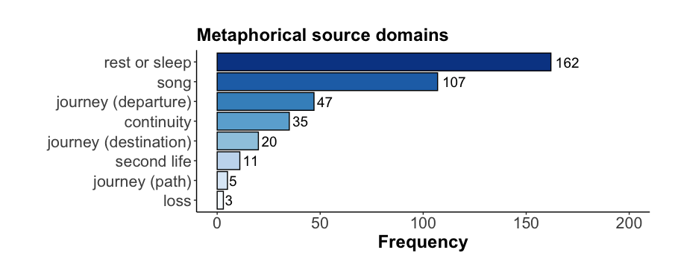
Figure 3. Frequency of metaphorical source domains for Bowie’s death

It is worth noting that the specification of the journey domain that attracts more popularity in the corpus is the one that profiles the departure (N=47, 12%, as in “you left us so soon”), followed by the destination (N=20, 5%, “Have fun in Mars”). The least emphasized aspect of the journey metaphor is path, found only in 5 messages in the corpus (2%; “Safe journey home”).
A closer look at the least prominent source domains also sheds light on loss as a highly residual choice for Bowie’s fans with only 3 instances, less than 1% of the corpus (“What a loss!”). This already hints at the scarce presence of negative or sad feelings in the mural, as is discussed in Section 4.3 below.
These results show that while Bowie’s death is partly conceptualized in terms of source domains which have traditionally been observed in other death related genres, such as rest/sleep, journey, continuity and second life, a representative part of the messages written on the mural makes use of the source domain song. In these cases, extracts from the lyrics of songs by Bowie are creatively re-used by fans, in such a way that they allow for a reframing of Bowie’s death in terms of the culturally specific world evoked by Bowie’s fictional universe rather than more traditional cultural metaphors. These different types of metaphors are discussed and illustrated in greater detail in the sections below.
To what extent are death metaphors in Bowie’s mural creative?
In other words, to what extent are the metaphors creative, conventional, or creatively used? As shown in Figure 4, most metaphorical source domains are exploited in conventional ways (N=240, 62%), with very few conventional source domains that explore secondary or novel connections between source and target domains (N=43, 11%). Interestingly, novel source domains are somewhere in between (N=107, 28%), thus supporting our original interest in investigating the creative make-up of the metaphors in Bowie’s mural.
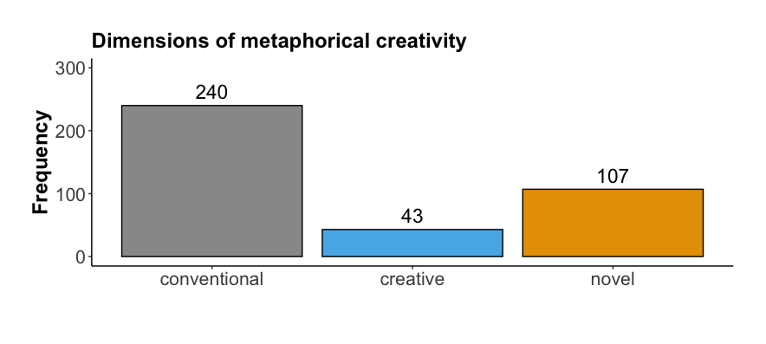
Figure 4. Distribution of metaphors in the corpus by dimension of creativity

Considering these three dimensions of creativity from the point of view of the metaphorical source domains (Figure 5), we find that novel metaphors fully overlap with those that rely on songs as metaphorical source domains. This is so because, even though some of the songs feature highly conventional metaphors, their occurrence in a highly specific context (the mural) makes them cast a new light on Bowie’s death, making them qualitatively more creative than recurrent death metaphors found in cemeteries. The rest of the metaphors in the corpus were classified as conventional and were further divided between conventionally or creatively deployed. Most source domains were developed in highly expectable ways, with a minimal share of examples featuring creative twists that projected new light on otherwise highly conventional sources. Interestingly, exceptions are journey metaphors that focus on the destination of Bowie’s journey after death, i.e. “space”, “Mars” and “stars”, recurrent themes in his music.
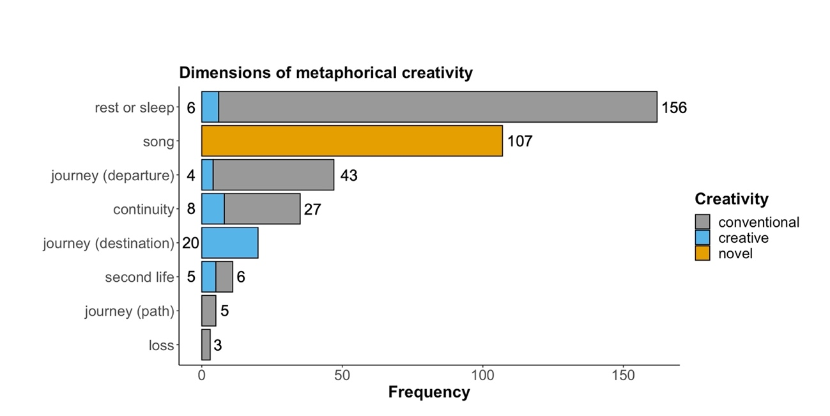Figure 5. Distribution of metaphorical source domains in the corpus by dimension of creativity

A Chi-square Test for Independence confirmed that there were significant patterns in the choice of the metaphorical source domain and the degree of creativity with which they were developed (X²(2) = 583.9, p< .001). The levelplot in Figure 6 below visualises Pearson’s residuals, a statistical test that shows the degree of creativity that is most likely to be associated with each metaphorical source domain, in a statistically significant way. In order to interpret the plot, green cells (which represent values over 2, with dark green representing values over 4, and therefore, stronger associations) mean there are more observations in the cell than what would be expected if there was a balanced distribution between dimensions of creativity and metaphorical source domain (i.e., null model, grey cells), and therefore constitute an over-represented combination of both source domain and creativity. Red cells (values under -2) mean there are fewer observations than would be expected, and therefore show an under-represented combination of a metaphorical domain and a given dimension of creativity in the corpus.
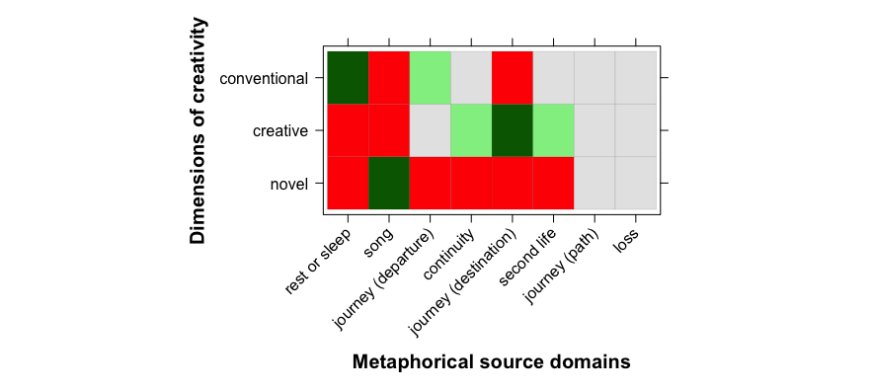
Figure 6. Pearson residuals from the Chi-square test showing the distribution of associations between metaphorical source domains and each dimension of creativity (green = stronger than chance)

The plot shows that there are two metaphorical domains that are statistically very likely to be developed in conventional ways: rest or sleep (very strong association) and journey metaphors highlighting aspects of the departure (strong association). These results are in line with previous research in the field (Marin-Arrese 1996, Crespo Fernández 2006, 2013, Wachowski and Sullivan 2021), which shows the frequency of journey and rest/sleep metaphors in epitaphs and obituaries.
Examples below illustrate the use of the conventional metaphorical source domains rest/sleep (examples 1 and 2) and journey as departure (examples 3 and 4) in messages which typically address David Bowie or one of his personas:
- RIP Starman
- Good night. Sleep well David
- Goodbye Starman
- See you later Ziggy...
Other typical uses of conventional metaphors in the corpus involve the source domains of continuity (examples 5-8) and second life (examples 9-10):
- You are the light of the world
- RIP the brightest star
- Ziggy Stardust - You live forever in our hearts
- Your body may have gone but your music will live on forever, you Legend
- May God be with you
- Dear Mr Bowie, you can sing to my beautiful sister now!
As can be observed in the examples above, the metaphor death is continuity (examples 5-8) relies on the concepts of light - which makes use of the more basic metaphors bowie is star and good is light - music and the heart as location for emotions and memory, while the metaphor death as second life (examples 9-10) relies on the Christian belief that death is typically conceptualized as a new life of the soul in heaven. This is typically understood as a joyful life, following the Christian belief that dying implies being finally free from life on earth as a ‘vale of tears’.
The scenario changes when we look closely into the ways in which conventional source domains are creatively deployed: in this case, the most likely source domain to feature a conceptual twist that departs from what would have been expected is a journey with a focus on the destination. As mentioned above, this may be because fans usually refer to Mars as the destination for such an afterlife trip, in line with the impersonation of Bowie in his persona Ziggy Stardust. This is illustrated in examples (11) to (13) below:
- Enjoy life on Mars, Starman
- If there wasn't life on Mars, there sure is now. Thank you... Ziggy.
- You went back to the stars. Love you forever, Goblin King
As commented above, these journey metaphors which highlight space, and specifically, Mars, as destination, make use of the primary metaphors states are locations and good is up. They are culturally motivated context-induced metaphors (Kövecses 2005, Sharifian 2015) which draw from knowledge and assumptions shared by the Bowie fan community regarding the fictional universe of his songs and films. It can be argued that fans, when writing these creative messages, perform metaphoric enactment (Gibbs 2019) in the sense that they enter Bowie’s fictional universe and address him or his personas in an act of suspension of disbelief, as if he were really Ziggy Stardust and was indeed now living in Mars. In this sense, these creative metaphors show that Bowie’s death is here framed in a playful and imaginative way in which the traditional Christian concept of going to heaven after death is substituted by the new understanding of death within Bowie’s universe as going back to space.
To a lesser extent, but still statistically significant, we find strong associations between continuity (14) and second life (15-16) as metaphorical source domains that are creatively exploited, illustrated below:
- You will always be my ‘star’ man
- You can sing Under Pressure with Freddie again!
- I hope you are duetting with Kurt .... In space xxx
While example (14) creatively elaborates on the conventional bowie is star metaphor, examples (15) and (16) conceptualise death as second life by evoking details of Bowie’s life and fictional universe in playful ways which exploit the Christian belief that after death people go to heaven and can meet other dead friends and relatives and perform different kinds of everyday activities.
While most of bowie’s death is rest/sleep metaphors are conventional, there are a few examples which illustrate the creative use of this source domain, as in example (17), were the word “peace” has been substituted by “space”, much in line with the imagery of Ziggy Stardust and song themes about Mars and space:
- Rest in space you amazing inspirational man!
Finally, and as advanced above, the re-use of Bowie’s songs is expected to project novel, one-off source mappings onto the artist’s death. As argued above, Bowie’s songs acquire a totally new meaning by being embedded in a highly contextualized shrine that commemorates the artist’s death. Novel mappings can be broken down into two further types: lines from songs reproduced verbatim (where new meaning comes from the context, i.e. shrine) and modified lyrics (adapted to the situation). Examples of the latter are numerous variations which are made of the theme from the song Starman which says literally ‘There’s a Starman waiting in the sky’, as in examples (18) and (19) below:
- The Starman really is waiting in the sky
- Starman high in the sky shining brightly down on us xxx
Other themes from songs are taken up as a point of departure for a message, such as the song Changes, mentioned in example (20) and the song Heroes in (21):
- "Changes" happen, memories & music stay!
- You were a hero for more than one day. Thank you Starman
In the cases in which the extracts from lyrics are reproduced verbatim, it can be argued that a process of recontextualization takes place, in such a way that the line from the song is appropriated by the fan community in the new context of Bowie’s death as talked about at the shrine, potentially endowing it with a new meaning. The meaning of these lines from lyrics is ambiguous, in the sense that they can be taken to be, on the one hand, verbatim reproductions of lines from Bowie’s songs which fans are particularly fond of, and one the other, a potential metaphoric conceptualisation of Bowie’s death by borrowing source domains from his own songs. Good examples of this are illustrated in examples (22) to (27) below. The titles of the songs from which the lines are extracted are included in brackets:
- Planet earth is blue and there’s nothing I can do (Space Oddity)
- The stars look very different today (Space Oddity)
- Put on my red shoes and dance the blues.... (Let’s dance)
- We can be heroes (Heroes)
- Oh no love, you're not alone (Rock ‘n roll suicide)
- Hot tramp, I love you so (Rebel Rebel)
By reproducing these lines or titles from songs, it can be argued that fans are creatively reframing Bowie’s death by conceptualizing it in terms of themes from his songs. The repetition of the lyrics thus functions both as a tribute to the artist’s music and as a creative strategy to deal with the artist’s death by appealing to his fictional universe as if this were a source for consolation. Some of the lyrics highlight the concept of continuity ((25) “We can be heroes”), while others seem to focus on the emotions which the death of the artist inspires in fans ((24) “Put on my red shoes and dance the blues”, (27) “Hot tramp I love you so”). Some of the emotions of sadness are grounded on the metaphor emotions are colours, as in (22) “planet earth is blue” and (24) “dance the blues”, where blue conventionally evokes sadness (Allan 2007).
The process of appropriation and recontextualization of the lyrics can be said to take place by means of a deictic shift which enables a move from the fictional universe of Bowie’s songs to the real world where the imagined interaction between the fans and Bowie at the shrine takes place. The new interpretation is possible given that most noun phrases used in the lyrics can be interpreted as referring to different entities and locations in different contexts (Hidalgo Downing and Filardo Llamas 2020: 92-93). In this way, for example, the lines in (22) “planet earth is blue and there’s nothing I can do” and in (23) “the stars look very different today” which were uttered by astronaut Major Tom on his space journey in the song Space Oddity, can be interpreted as acquiring a different meaning when reused by the fans in the shrine, who seem to use the lines to reflect on how they feel about Bowie’s death. Similarly, lines from his songs such as (2) “we can be heroes”, (26) “oh no love, you’re not alone”, and (27) “hot tramp I love you so”, are taken up by the fans to address Bowie himself or one of his personas.
What is the most frequent emotional connotation of the metaphorical framings for Bowie’s death?
In this research question, we explore the extent to which the conceptualization of death in the metaphors identified in Bowie’s mural evokes positive or negative connotations. Positive connotations (e.g. feelings of hope), which, according to the literature are euphemistically motivated, were across the board the most prevalent ones (N=361, 93%), with negative connotations (e.g. feelings of sadness, N=25, 6%) and mixed connotations (N= 4, 1%) playing a residual role (see Figure 7).
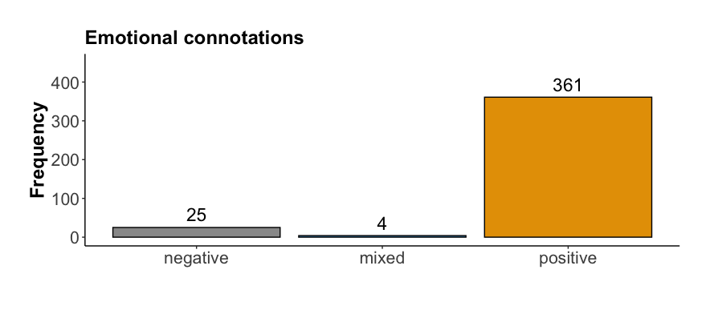
Figure 7. Distribution emotional connotations in the metaphors in the corpus

Figure 8 shows a breakdown of connotations projected by metaphorical source domain. In consonance with the results seen above, all metaphorical source domains (except that of loss) evoke positive connotations, endowing the mural with an overall aura of hope, gratitude and optimism. Naturally, the highest frequency of positive messages coincides with the metaphorical source domain rest/sleep (N=161, 99%), the most frequent one in the corpus. Positive connotations are prevalent in four other metaphorical source domains (journey-destination, N= 20; second life, N=11; and journey-path, N=5; 100% of the instances in all three cases), and the vast majority in the case of continuity (N=34, 97%).
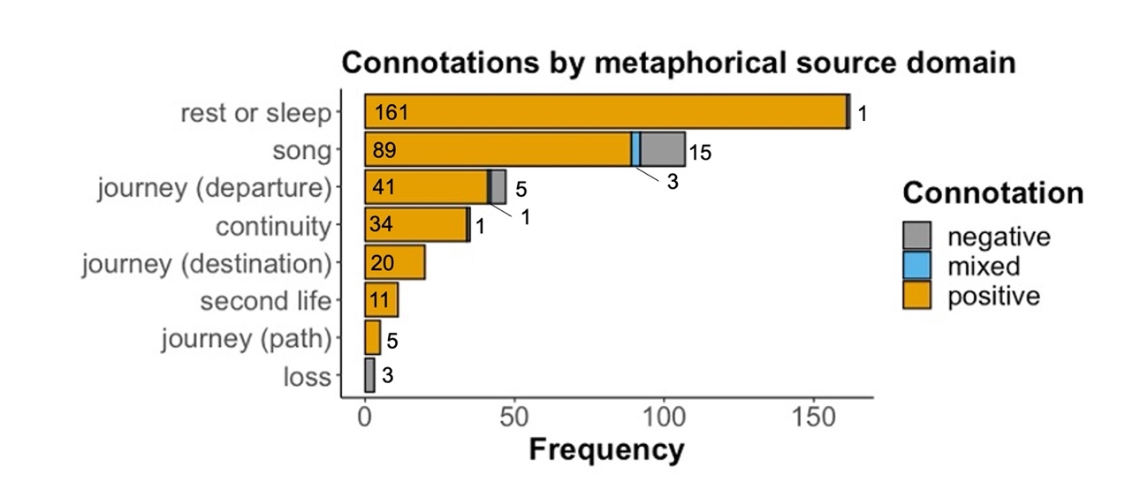
Figure 8. Distribution types of feelings by metaphorical source domain in the corpus

As observed above and illustrated by most of the examples discussed so far, the positive connotations of metaphors with the source domains rest/sleep, journey, continuity and second life arise from the conceptualization of death as a transitory rather than a permanent state (Crespo Fernández 2013: 106). Numerous examples of these have been illustrated in the preceding sections. A case in point are the metaphors involving Bowie’s songs as metaphorical source domains; even though most recorded connotations are positive (N=89, 83%), it is precisely the inherent creativity of these one-off frames that gives room to the expression of alternative feelings with some negative (N=15, 14%) and mixed (N=3, 3%) connotations. Negative connotations can also be found, but to a lesser extent, in metaphorical mappings involving the departure of the deceased (N=5, 11%) and loss (N=3, 100%). In these cases, the journey metaphor typically co-occurs with an explicit expression of sadness, as in (28):
- So sad you left the planet
The proportion of positive, negative and mixed connotations differed with respect to the metaphorical source domain involved in a statistically significant way (X² (2) = 95.352, p<.001). A closer look at the Pearson residuals shown in the levelplot in Figure 9 reveals that the differences did not apply to positive feelings, as they were the most salient ones for all the metaphorical source domains under scrutiny. The significant differences had to do with the ways in which negative feelings were strongly associated with the metaphorical source domain of loss (“what a loss!”), and to a lesser extent but still significant, mixed feelings with metaphors involving songs, perhaps due to the markedly creative spirit of such mappings.
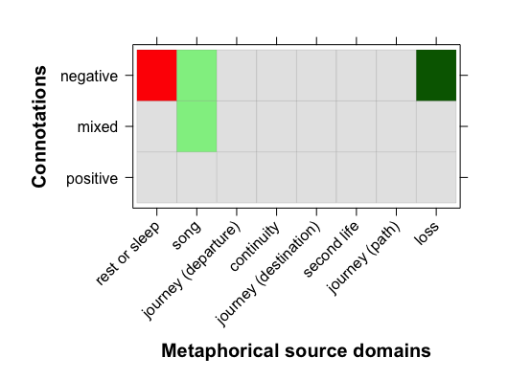
Figure 9. Pearson residuals from the Chi-square test showing the distribution of associations between metaphorical source domains and types of feelings (green = stronger than chance)

A final aspect of interest is the connection between the positivity/negativity of the connotations expressed in the mural and the creativity of the metaphorical messages.

Much in line with the findings reported in this section, Figure 10 confirms that positive connotations are the most frequent in conventional, creative and novel metaphors, and also in similar proportions (conventional, N=229, 95%; creative, N=43, 100%; novel, N=89, 83%). Novel and conventional metaphors also projected some negative connotations, although in a residual way (N= 15, 14%, and N=10, 4%, respectively). Mixed connotations were found in conventional metaphors (N=1, 0.5%) and novel metaphors ( N=19, 9%; recall here that these are mostly metaphors involving some song as source domain).

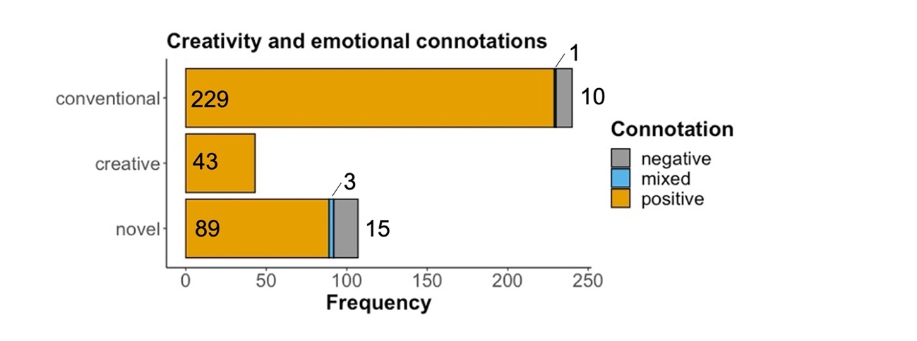
Figure 10. Distribution types of feelings by each dimension of creativity in the corpus

Novel metaphors, all of which had the source domain song, were annotated as invoking positive connotations of hope when the reproduced titles or lines from songs highlighted the idea of continuity, as in examples (29) and (30) below, or the extracts from the lyrics co-occurred with co-text which had a positive connotation, as in (31). In all these cases, the song metaphorical source domain was interpreted as a celebration and a tribute to Bowie’s music:
- There’s a Starman waiting in the sky
- Ground control to Major Tom
- The stars look very different today. Shine forever, Starman xx
Novel metaphors were interpreted as expressing negative connotations and sadness in lines and titles from songs about death, such as those from the album Blackstar, in which Bowie reflects on his own death and mortality (example 32), and others which expressed negative feelings and sadness as in (33) and (34):
- Blackstar (Blackstar)
- All the nightmares came today - And it looks as though they're here to stay (Oh you pretty things)
- Put on your red shoes and dance the blues (Let’s Dance)
Connotations were coded as mixed in messages which were open to more than one interpretation in terms of the potential feelings, as in examples (35) and (36):
- The stars look very different today (Space Oddity)
- Ashes to ashes, funk to funky (Ashes to Ashes)
We interpreted (35) as evoking mixed connotations, depending on whether it could be understood that Bowie is now back in the stars (hope) or as reflecting on the artist's absence (sadness). Similarly, example (36) was interpreted as potentially expressing mixed emotions by invoking death through the metonymic expression “ashes to ashes” and at the same time hope, in the expression “funk to funky”, which seemed to point at the continuity of Bowie’s music after his death. In this sense, the lines from the songs in these two examples are recontextualised in order to refer to Bowie’s death and music and not to the situations described in the songs, which refer to Major Tom’s travels in space, or, allegorically, to drug trips.
All in all, our enquiry into the relationship between creativity and emotional connotation consolidates our findings on the relationship between emotional connotation and metaphorical source domains: positive feelings were the most pervasive ones across the board, and therefore we could not establish a type of creativity that is more likely than another in projecting positive connotations. Positive feelings were manifested conventionally, creatively, and through one-off mappings. However, as can be seen in Figure 11, there were significant associations between creativity and connotation that once again, had to do with the likelihood of novel metaphors to project negative connotations, in a way that was significantly different from conventional and creative mappings (X²(2) = 25.243, p<.001).
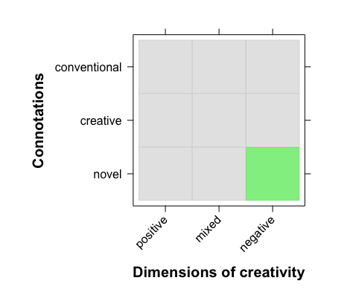
Figure 11. Pearson residuals from the Chi-square test showing the distribution of associations between dimensions of creativity and types of feelings (green = stronger than chance)

Conclusions
This article has studied the creative metaphorical framing of death in the messages written on David Bowie’s mural in London. Results show that regarding RQ1, the most frequent source domains are rest/sleep and journey, followed by song, continuity, second life and loss. A significant finding was the identification of a new source domain, i.e. song, which is frequent in statistical terms, and is used by fans to reframe the artist’s death from a novel perspective. With respect to RQ2, results showed that, although there is a predominance of conventional metaphorical source domains, there were interesting correspondences between degree of creativity and source domains. Thus, while most conventional metaphors featured death as rest/sleep and journey as departure, creative uses of conventional metaphors featured journey as destination, and all uses of novel metaphors displayed the source domain song. We have argued that the recontextualization of extracts from Bowie’s songs, as well as the creative exploitation of conventional source domains contribute to reframing the conceptual domain of death in the mural in highly creative and unexpected ways. Finally, in answer to RQ3, our results show that most metaphors evoke positive connotations (feelings of hope), while negative and mixed connotations played a residual role in the corpus.
All in all, this study has contributed to advancing research on the metaphorical conceptualization of death in several ways: first, a previously unexplored discourse type has been studied, an urban mural, which has confirmed the need to analyse the metaphorical conceptualization of death not only as a cognitive phenomenon, but also as a highly contextualised and culturally-based social practice. Second, a new source domain for the understanding and framing of death has been proposed, that of song. We have argued that this source domain has been used by fans writing on the mural to create novel highly idiosyncratic cultural metaphors inspired in Bowie’s songs, which function both as consolatory metaphors which expand on the idea of the continuity of the artist’s presence through his music and fictional universe, but also as celebrations and tributes to the artist’s life and death. While these results confirm tendencies identified in previous research in the field regarding the predominance of rest/sleep and journey metaphors in the conceptualization of death, further research is needed in areas such as the contextual and socio-cultural motivation of death metaphors, the occurrence and motivation of creative death metaphors in different genres and the extent to which creative death metaphors are euphemistically motivated. Some limitations can be observed in the present study, which may serve as a point of departure for future research. It is obviously not possible to prove whether the lines from the songs which we interpreted as activating song metaphors were indeed written by fans with this communicative purpose in mind. Future experimental studies could be performed to test the interpretation of the potential metaphoric meaning and emotional connotations of these lines from songs.

References
Allan, K. and K. Burridge. 2006. Forbidden Words: Taboo and the Censoring of Language. Cambridge: Cambridge University Press.
Allan, Keith. 2007. ‘The connotations of English colour terms: Colour-based X-phemisms.’ Journal of Pragmatics 41: 626-637.
Bowie, D. 1972. The rise and fall of Ziggy Stardust and the Spiders from Mars. RCA Records.
Bowie, D. 1973: Aladdin Sane. RCA Records.
Carrington, V. and C. Dowdall. 2016. ‘Vernacular creativity in urban textual landscapes.’ In R. Jones (Ed.) The Routledge Handbook of Language and Creativity. Abingdon: Routledge, (pp. 415–429).
Cinque, T. and S. Redmond. 2019. The fandom of Bowie: Everybody says Hi. MacMillan.
Crespo Fernández, E. 2006. ‘The Language of Death: Euphemism and Conceptual Metaphorization in Victorian Obituaries.’ SKY Journal of Linguistics 19: 101–130.
Crespo-Fernández, E. 2011. ‘Euphemistic conceptual metaphors in epitaphs from Highgate cemetery.’ Review of Cognitive Linguistics 9/1: 198-225.
Crespo Fernández, E. 2013. ‘Euphemistic Metaphors in English and Spanish Epitaphs: A Comparative Study.’ ATLANTIS, Journal of the Spanish Association of Anglo-American Studies 35/2: 99-118.
Crespo-Fernández, E. 2014. El lenguaje de los epitafios. Ediciones de la Universidad de Castilla-La Mancha.
Fuoli, M., J. Littlemore, and S. Turner. 2022. ‘Sunken Ships and Screaming Banshees: Metaphor and evaluation in film reviews.’ English Language and Linguistics 16/1: 75-103.
Gatambuki Gathigia, M., R. Wang, M. Shen, C. Tirado, O. Tsaregorotseva, O. Khatin-Zadeh, R. Minervino, F. Marmolejo-Ramos, Fernando. 2018. ‘A cross-linguistic study of metaphors of death’. Cognitive Linguistics 5/2: 359-375.
Gibbs, R. W. Jr. 2019. ‘Metaphor as Dynamical–Ecological Performance.’ Metaphor and Symbol 34/1: 33–44.
Gibbs, R. W. Jr. & Cameron, L. 2008. ‘The social-cognitive dynamics of metaphor performance.’ Cognitive Systems Research 9: 64-75.
Herrero Ruiz, J. 2007. ‘At the crossroads between literature, culture, linguistics, and cognition: Death metaphors in fairy tales.’ Revista Española de Lingüística Aplicada 20: 59-84.
Hidalgo-Downing, L. 2017. ‘Última parada: el mural de David Bowie en Londres. Un recorrido espacial, sonoro y sensorial a través de la memoria.’ Actas del III Congreso Internacional de Espacios Sonoros y Audiovisuales. La ciudad como lugar de experimentación, creación e investigación plurisensorial. Madrid: Universidad Autónoma de Madrid, e-publication (pps. 179-191).
https://drive.google.com/file/d/0B6bRKOOatXBsLW16RnhJZklLVjQ/view?resourcekey=0-wdKqnMruombGBjHKW5F1_A [accessed 16/05/2022]
Hidalgo-Downing, L. 2020. ‘Introduction: Towards an integrated framework for the analysis of metaphor and creativity in discourse.’ In Hidalgo-Downing, Laura and Blanca Kraljevic-Mujic (eds.). Performing Metaphoric Creativity Across Modes and Contexts. Amsterdam: John Benjamins, pps. 1-8.
Hidalgo-Downing, L. and L. Filardo-Llamas. 2020. ‘Singing for peace. Metaphor and creativity in the lyrics and performances of three songs by U2.’ In Hidalgo-Downing, Laura and Blanca Kraljevic-Mujic (eds.) Performing Metaphoric Creativity Across Modes and Contexts. Amsterdam: John Benjamins, pps. 71-96.
Harju, A. 2015. ‘Socially shared mourning: construction and consumption of collective memory.’ New Review of Hypermedia and Multimedia 21/1–2: 123–145.
Helmers, M. 2001. ‘Media, Discourse, and the Public Sphere: Electronic Memorials to Diana, Princess of Wales.’ College English 63/4: 437-456.
Heynderickx, P. and S. S. Dieltjens. 2021. Politics beyond death: an analysis of the obituaries of Belgian politicians. In E. Crespo-Fernández (Ed.), Discourse Studies in Public Communication. Amsterdam: John Benjamins, (pp. 129-148).
Holt, G. 2016. ‘David Bowie fans create makeshift London shrines.’ BBC News. https://www.bbc.com/news/entertainment-arts-35283801. [Accessed 23/02/2022]
Jensen, T. W. & Cuffari, E. 2014. ‘Doubleness in experience: Toward a distributed, enacted approach to metaphoricity.’ Metaphor and Symbol 29/4: 278–297.
Jones, R. (Ed.) 2016. ‘Creativity and discourse analysis.’ In R. Jones (Ed.), The Routledge handbook of language and creativity. Abingdon: Routledge, (pp. 61–77).
Kövecses, Z. 2005. Metaphor in Culture. Universality and Variation. Cambridge: Cambridge University Press.
Kövecses, Z. 2010. ‘A new look at metaphorical creativity in cognitive linguistics.’ Cognitive Linguistics 21/4: 663–97.
Lakoff, G., and Johnson, M. 1980. Metaphors We Live by. Chicago: University of Chicago Press.
Lakoff, G., and M. Turner. 1989. More than cool reason: A Field Guide to Poetic Metaphor. Chicago: University of Chicago Press.
Lakoff, G., J. Espenson, A. Goldberg and A. Schwartz. 1991. Master Metaphor List (second edition). Accessed online [1/12/2021] METAPHORLIST.pdf (uic.edu)
Lu, W. 2017. Cultural conceptualisations of death in Taiwanese Buddhist and Christian eulogistic idioms. In F. Sharifian (Ed.), Advances in Cultural Linguistics Singapore: Springer Nature, (pp. 49–64).
Marin-Arrese, J. I. (1996) ‘To die, to sleep, a contrastive study of metaphors for death and dying in English and Spanish.’ Language Sciences 18/1-2: 37-52.
Matley, D. 2020. ‘“I can’t believe #Ziggy #Stardust died”: Stance, fan identities and multimodality in reactions to the death of David Bowie on Instagram.’ Pragmatics, 30/2: 247-276.
Pérez-Sobrino, P., J. Littlemore and S. Ford. 2021. Unpacking Creativity. The Power of Figurative Communication in Advertising. Cambridge: Cambridge University Press.
Pérez-Sobrino, P., E. Semino, I. Ibarretxe-Antuñano, V. Koller and I. Olza. 2022. ‘Moving like a hedgehog in times of the pandemic.’ Metaphor and Symbol. In press.
R Core Team. 2020. R: A language and environment for statistical computing. R Foundation for Statistical Computing, Vienna, Austria. https://www.R-project.org/.
Sarkar, D. 2008. Lattice: Multivariate Data Visualization with R. Springer, New York.
Semino, E. 2008. Metaphor in discourse. Cambridge: Cambridge University Press.
Semino, E., A. Deignan, and J. Littlemore. 2013. ‘Metaphor, genre and recontextualization.’ Metaphor and Symbol 28/1: 41–59.
Semino, E., Z. Demjén, A. Hardie, S. Payne and P. Rayson. 2019. Metaphor, Cancer and the End of Life. A Corpus-Based Study. London: Routledge.
Sharifian, F. 2015. Cultural linguistics. In F. Sharifian (Ed.) The Routledge Handbook of Language and Culture. London: Routledge. (pps. 473-492).
Steen, G.; Dorst, A.; Herrmann, J.; Kaal, A.; and Krennmayr, T. 2010. ‘Metaphor in usage.’ Cognitive Linguistics 21/4: 765-796.
Van Dijk, T.A. 2009. Discourse and Context: A Sociocognitive Approach. London: Sage.
Wachowski, W. and K. Sullivan. 2021. Metonymies and Metaphors for Death Around the World. New York: Routledge.
Wickham, H. 2016. ggplot2: Elegant Graphics for Data Analysis. Springer-Verlag: New York.

Funding for this study has been granted by the Ministry of Science, Innovation and Universities/FEDER (projects with references PID2020-118349GB-I00 and PGC2018-095798-B-I00) and the Government of Aragón (LMP143_21).
Author 1 and Author 2 have contributed equally to this research paper, and therefore should be both considered joint first authors.
See Crespo-Fernández (2011, 2014) for an analysis of politically-oriented epitaphs, in which the metaphor to die is to fall for God and Spain, dedicated to those who got killed during the Spanish Civil War (1936-39), plays a prominent role.
For an account of the urban trajectory performed in London to visit the mural, see Hidalgo-Downing (2017).

